Feather Icons
Pluggable widget for Mendix Studio Pro 10.24.17
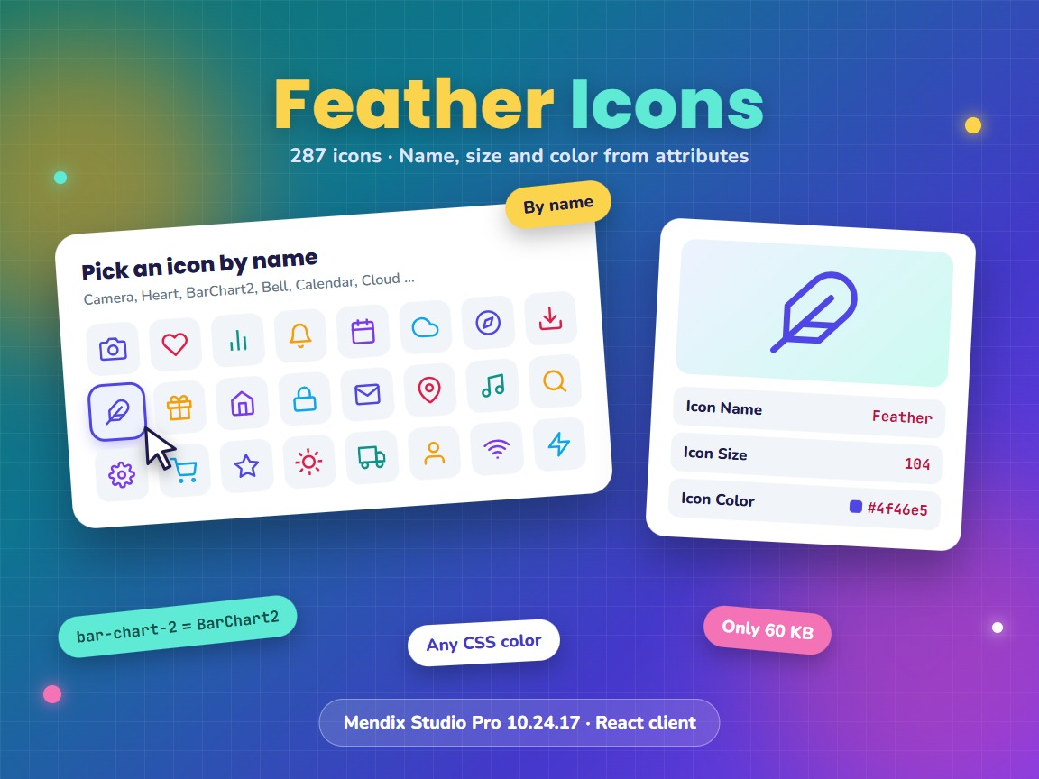
Item | Value
Widget version | 1.1.0
Studio Pro version | 10.24.17 (tested on 10.24.17.102810)
Widget ID | mendix.feathericons.FeatherIcons
Widget package | mendix.FeatherIcons.mpk (about 60 KB)
Platform | Web, React client (offline capable)
Icon library | react-feather 2.0.10 (287 icons)
Build tooling | @mendix/pluggable-widgets-tools 10.16.0
Source and downloads | github.com/bharathidas/FeatherIcons
Example module | FeatherSample.mpk (Studio Pro 10.24.17)

Contents

1. Overview
Feather Icons shows one icon from the open-source Feather icon set. The icon name, the size and the color are read from attributes of the context object, so the icon can be different for every object and can change at runtime.
The icons are simple line drawings in SVG format. They stay sharp at every size and take the color you give them.
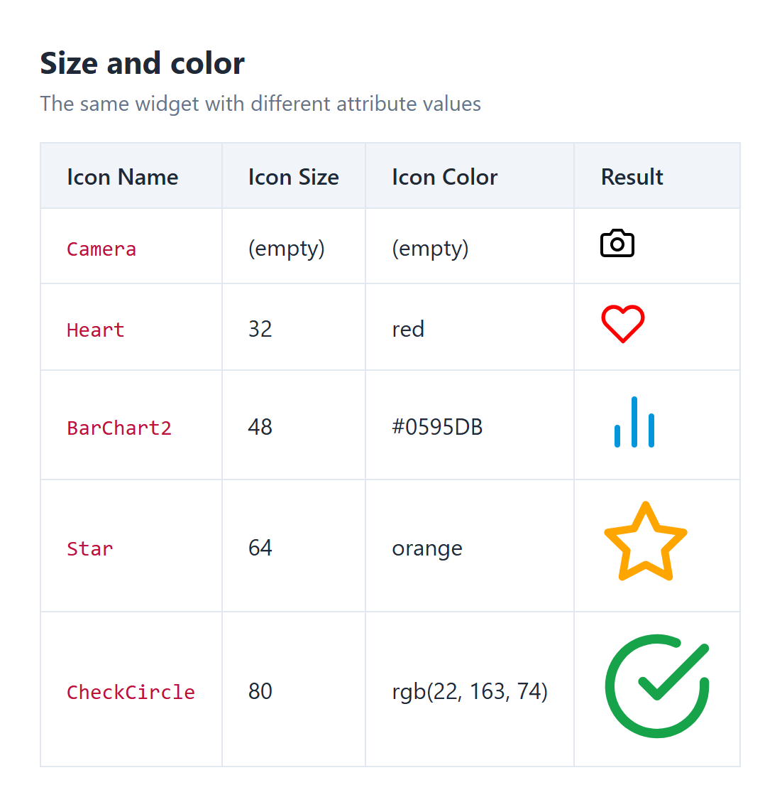
Figure 1. Illustration: the same widget with different attribute values

Typical uses
- Status icons in a list, for example a check mark for delivered and a clock for waiting
- Menu tiles or dashboard cards where the icon is stored with the data
- Category or type icons that an administrator can choose without a new deployment
- Any place where the icon depends on the object instead of being fixed on the page

2. What is new in version 1.1.0
- Rebuilt for Mendix Studio Pro 10.24.17 with @mendix/pluggable-widgets-tools 10.16.0, as a production build. The package is about 60 KB; version 1.0.0 was about 800 KB.
- The icon name is no longer case-sensitive and may contain dashes or spaces. BarChart2, barchart2, bar-chart-2 and bar chart 2 show the same icon. Names that worked in 1.0.0 still work.
- An empty Integer size attribute, which Mendix passes as 0, and negative sizes use the default size 24. In 1.0.0 the icon was invisible.
- A color that contains only spaces uses the default color black.
- The class and style set on the Appearance tab are applied. The icon is wrapped in a span with the class widget-feathericons.
- An empty icon name shows nothing, and nothing is shown while the value is loading. An unknown icon name still shows the text "Icon not found".
- The icon has aria-hidden="true", so screen readers skip it.
- Studio Pro design mode shows the Feather logo icon instead of "Icon not found".
- Clearer property descriptions. The property keys are unchanged, so existing pages keep their settings.

3. Requirements
- Mendix Studio Pro 10.24.17 or a later 10.24 version.
- A web profile. The widget is not available for native mobile.
- No other modules or libraries are needed.

4. Installation

4.1 Install the widget
- Download mendix.FeatherIcons.mpk from the Mendix Marketplace or from the GitHub release Version1.1.0.
- Copy the file into the widgets folder of your app. To find the folder, use App > Show App Directory in Explorer in Studio Pro.
- In Studio Pro, choose App > Synchronize App Directory (F4).
- The widget appears in the Toolbox as Feather Icons.

4.2 Upgrade from version 1.0.0
- Replace mendix.FeatherIcons.mpk in the widgets folder with the 1.1.0 file.
- Synchronize the app directory (F4).
- Studio Pro reports that the widget definition has changed. Right-click the error and choose Update all widgets. Your settings are kept.
- If the running app still shows the old widget, stop it, choose App > Clean Deployment Directory, and run it again.
Check after upgrading: the icon is now inside a span element. If you have custom CSS that selects the svg as a direct child of your own container, change the selector.

4.3 Try the example module
The example module FeatherSample contains the entity FeatherIcon (Name, Size, Color), the microflow MyFirstLogic that creates an object with the icon BarChart, size 30 and color red, and the page Home_Web that shows the icon. It includes the 1.1.0 widget.
- Download FeatherSample.mpk from the GitHub repository.
- In Studio Pro, right-click the app in the App Explorer, choose Import module package and select the file.
- Add the page FeatherSample.Home_Web to the navigation and run the app.
The page uses the Atlas_Default layout from Atlas_Core, which every standard app contains. Change the values in the microflow to try other icons.

5. Configuration

5.1 Prepare the domain model
Add a String attribute for the icon name to your entity, persistable or non-persistable. Optionally add an Integer attribute for the size and a String attribute for the color.
Attribute (example) | Type | Example value
IconName | String | Camera
IconSize | Integer | 32
IconColor | String | #0595DB

Tip: give the attributes default values in the domain model, for example IconName = Circle. New objects then show an icon immediately.

5.2 Place the widget on a page
- Add a data view or a list view with the entity as context. The widget needs a context object.
- Drag Feather Icons from the Toolbox into it.
- Double-click the widget and select the Icon Name attribute.
- Optionally select the Icon Size and Icon Color attributes.

5.3 Set the values
Set the attribute values in a microflow or nanoflow, in the data source, or let users type them in a text box. For example, in a Change object action:
IconName = if $Order/Status = Shop.Status.Delivered then 'CheckCircle' else 'Clock'
IconColor = if $Order/Status = Shop.Status.Delivered then '#16a34a' else '#f59e0b'
The widget only reads the attributes. It never changes them.

6. Property reference
All properties are on the General tab. Every property is an attribute of the context object.
Property | Attribute type | Description (when empty)
Icon Name (required) | String | Name of the Feather icon, for example Camera. Case, dashes and spaces are ignored. (Nothing is shown.)
Icon Size | Integer | Width and height of the icon in pixels. (24; also used for 0 and negative values.)
Icon Color | String | Any CSS color, for example red, #0595DB, rgb(22, 163, 74) or currentColor. (black)

The Common and Appearance tabs are the standard Studio Pro tabs. The Class and Style of the Appearance tab are applied to the span around the icon.

7. Icon names
Use the names of the Feather icon set. You can look up icons on feathericons.com. The site shows names with dashes, such as bar-chart-2; the widget accepts these names as well as the names without dashes.
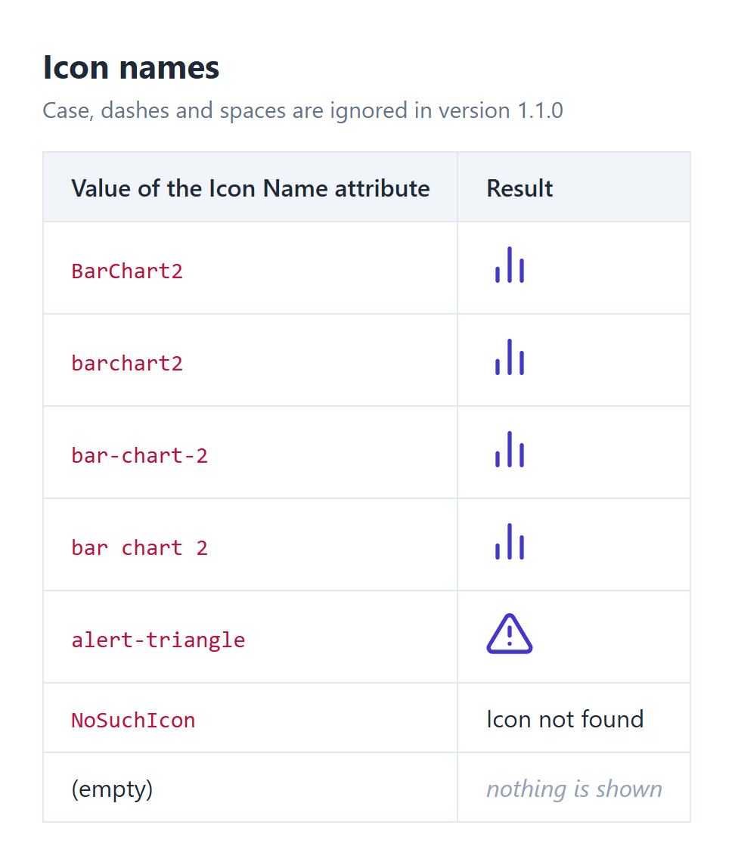
Figure 2. Illustration: how the value of the Icon Name attribute is read
The widget contains all 287 icons of react-feather 2.0.10. The full list is in chapter 13.

8. Size and color
- Size is the width and the height in pixels. The icons are square. The line thickness grows with the size.
- Color is the line color. Feather icons are line icons; they have no fill color.
- Use the value currentColor to give the icon the text color of its surroundings, for example inside a button or a colored label.
- An invalid color value makes the icon invisible, because the browser then draws no line. Check the spelling of the color when an icon is missing.

9. Styling
The widget renders this HTML:
<span class="widget-feathericons your-class" style="your style">
<svg width="24" height="24" stroke="black" aria-hidden="true" ...>...</svg>
</span>
The span is an inline block, so the icon can stand in a line of text. To align an icon with a text next to it, add a style on the Appearance tab, for example vertical-align: middle, or place both in a container with a flex row layout.
An unknown icon name is shown as the text "Icon not found" in a span with the extra class widget-feathericons-not-found. To hide this text, add this rule to your theme:
.widget-feathericons-not-found { display: none; }

10. Examples

10.1 Status list
Entity Order with the attributes StatusIcon and StatusColor, set in the microflow that changes the status. A list view shows one Feather Icons widget per row.
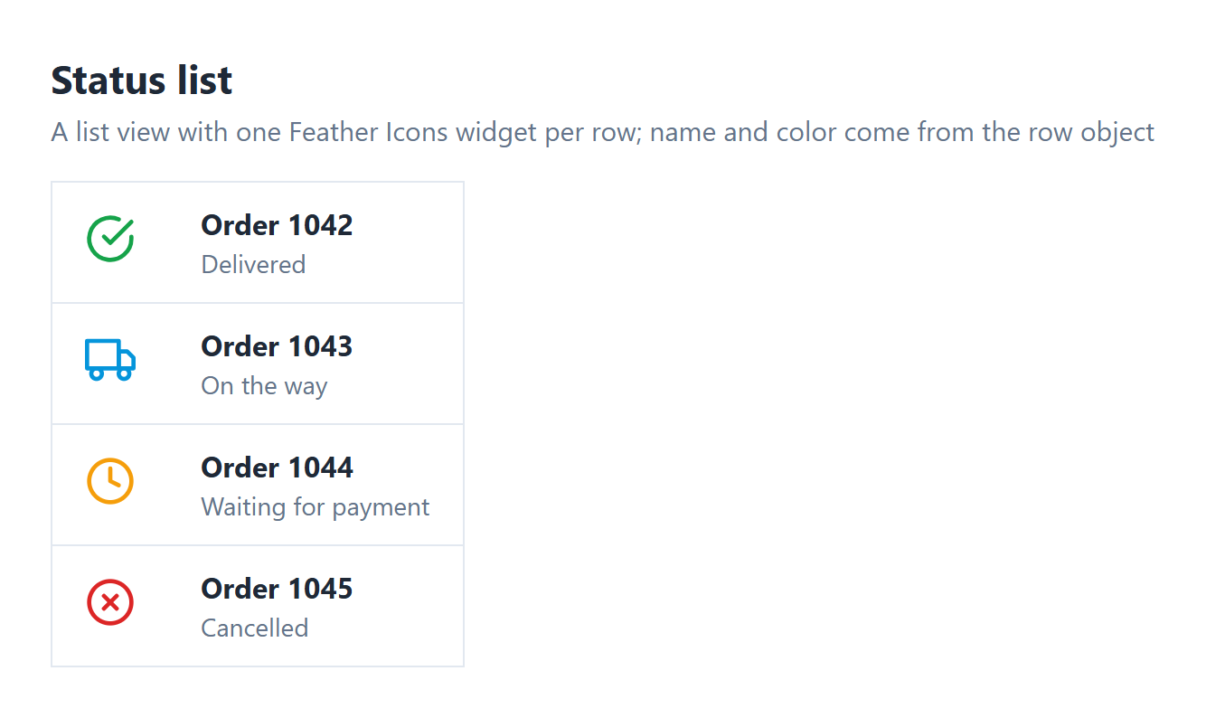
Figure 3. Illustration: a status list with an icon and a color per row

10.2 Icon chosen by an administrator
Entity Category with the attribute IconName. The edit page has a text box for IconName and a Feather Icons widget next to it. The icon changes when the user leaves the text box, so the administrator sees at once whether the name is correct.

10.3 Icon in the text color
Set the color attribute to currentColor. The icon then follows the text color of the container, also when the theme or a design property changes it.

11. Known behaviour and limitations
- The name, size and color are attributes. Static values cannot be typed in the widget properties; use attribute default values or set the values in a microflow.
- The widget needs a context object, so it must be inside a data view or list view.
- The icon name must be a String attribute. Enumeration attributes cannot be selected.
- The line thickness cannot be set. It is 2 units on the 24-unit drawing, and scales with the size.
- The default color is black, not the theme color. Use currentColor to follow the theme.
- The widget has no on-click action. Put it in a container with an on-click action.
- The icon is decorative for screen readers (aria-hidden). Add a text next to it when the meaning is important.
- The icon set is fixed to react-feather 2.0.10. Custom icons cannot be added.
- Web only; not available in native mobile apps.

12. Support and version history
Report issues, suggestions and feature requests on GitHub:
https://github.com/bharathidas/FeatherIcons/issues
Source code and all releases:
https://github.com/bharathidas/FeatherIcons
Widget | Studio Pro | GitHub release | Changes
1.1.0 | 10.24.17 | Version1.1.0 | Rebuilt for Studio Pro 10.24.17; flexible icon names; size and color fallbacks; class and style applied; smaller package; example module.
1.0.0 | 10.24.6 | Version1.0.0 | First release.

13. All icons
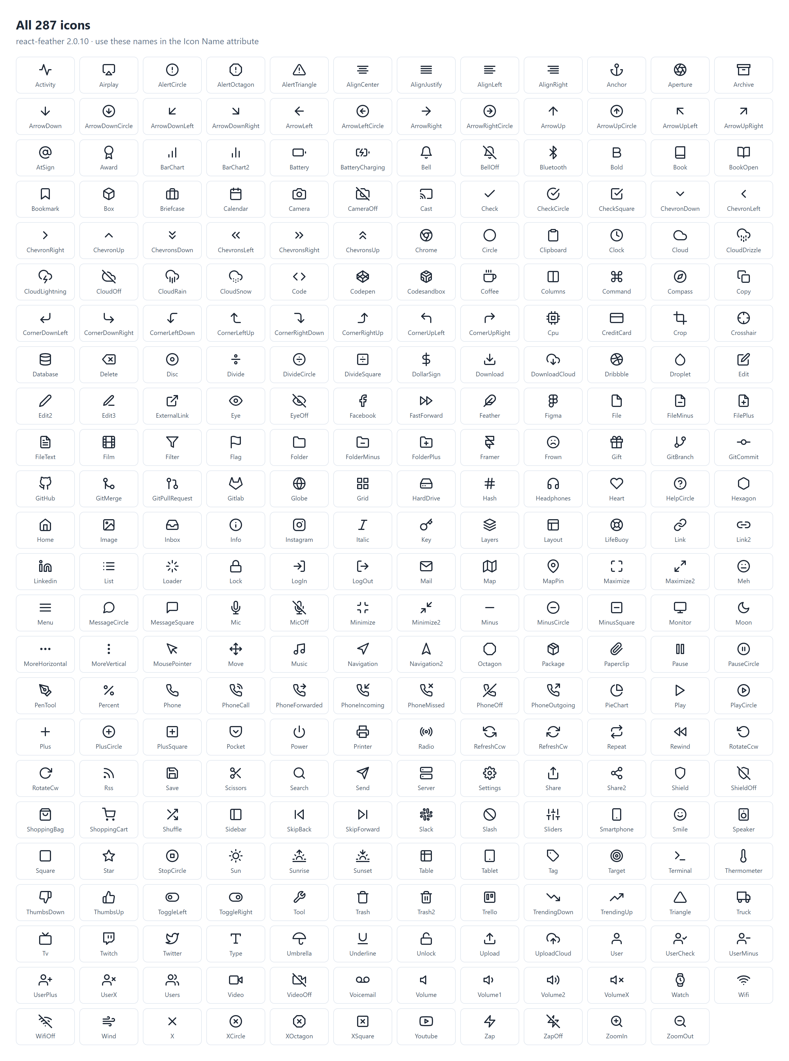
Figure 4. The 287 icons of react-feather 2.0.10 with their names

Names as text
Activity, Airplay, AlertCircle, AlertOctagon, AlertTriangle, AlignCenter, AlignJustify, AlignLeft, AlignRight, Anchor, Aperture, Archive, ArrowDown, ArrowDownCircle, ArrowDownLeft, ArrowDownRight, ArrowLeft, ArrowLeftCircle, ArrowRight, ArrowRightCircle, ArrowUp, ArrowUpCircle, ArrowUpLeft, ArrowUpRight, AtSign, Award, BarChart, BarChart2, Battery, BatteryCharging, Bell, BellOff, Bluetooth, Bold, Book, BookOpen, Bookmark, Box, Briefcase, Calendar, Camera, CameraOff, Cast, Check, CheckCircle, CheckSquare, ChevronDown, ChevronLeft, ChevronRight, ChevronUp, ChevronsDown, ChevronsLeft, ChevronsRight, ChevronsUp, Chrome, Circle, Clipboard, Clock, Cloud, CloudDrizzle, CloudLightning, CloudOff, CloudRain, CloudSnow, Code, Codepen, Codesandbox, Coffee, Columns, Command, Compass, Copy, CornerDownLeft, CornerDownRight, CornerLeftDown, CornerLeftUp, CornerRightDown, CornerRightUp, CornerUpLeft, CornerUpRight, Cpu, CreditCard, Crop, Crosshair, Database, Delete, Disc, Divide, DivideCircle, DivideSquare, DollarSign, Download, DownloadCloud, Dribbble, Droplet, Edit, Edit2, Edit3, ExternalLink, Eye, EyeOff, Facebook, FastForward, Feather, Figma, File, FileMinus, FilePlus, FileText, Film, Filter, Flag, Folder, FolderMinus, FolderPlus, Framer, Frown, Gift, GitBranch, GitCommit, GitHub, GitMerge, GitPullRequest, Gitlab, Globe, Grid, HardDrive, Hash, Headphones, Heart, HelpCircle, Hexagon, Home, Image, Inbox, Info, Instagram, Italic, Key, Layers, Layout, LifeBuoy, Link, Link2, Linkedin, List, Loader, Lock, LogIn, LogOut, Mail, Map, MapPin, Maximize, Maximize2, Meh, Menu, MessageCircle, MessageSquare, Mic, MicOff, Minimize, Minimize2, Minus, MinusCircle, MinusSquare, Monitor, Moon, MoreHorizontal, MoreVertical, MousePointer, Move, Music, Navigation, Navigation2, Octagon, Package, Paperclip, Pause, PauseCircle, PenTool, Percent, Phone, PhoneCall, PhoneForwarded, PhoneIncoming, PhoneMissed, PhoneOff, PhoneOutgoing, PieChart, Play, PlayCircle, Plus, PlusCircle, PlusSquare, Pocket, Power, Printer, Radio, RefreshCcw, RefreshCw, Repeat, Rewind, RotateCcw, RotateCw, Rss, Save, Scissors, Search, Send, Server, Settings, Share, Share2, Shield, ShieldOff, ShoppingBag, ShoppingCart, Shuffle, Sidebar, SkipBack, SkipForward, Slack, Slash, Sliders, Smartphone, Smile, Speaker, Square, Star, StopCircle, Sun, Sunrise, Sunset, Table, Tablet, Tag, Target, Terminal, Thermometer, ThumbsDown, ThumbsUp, ToggleLeft, ToggleRight, Tool, Trash, Trash2, Trello, TrendingDown, TrendingUp, Triangle, Truck, Tv, Twitch, Twitter, Type, Umbrella, Underline, Unlock, Upload, UploadCloud, User, UserCheck, UserMinus, UserPlus, UserX, Users, Video, VideoOff, Voicemail, Volume, Volume1, Volume2, VolumeX, Watch, Wifi, WifiOff, Wind, X, XCircle, XOctagon, XSquare, Youtube, Zap, ZapOff, ZoomIn, ZoomOut

